ASSIGNMENT 1
Q1 Identify one level network.
Tier 1 network is an Internet Protocol (IP) network that can reach every other network on the Internet simply via settlement-free interconnection, also known as settlement-free peering. There is no authority that defines tiers of networks participating in the Internet. Or we can say that Tier 1 network is a network that can reach every other network on the Internet without purchasing IP transit or paying for peering.
Q2 Identify Client-server network.
A client-server network is designed for end-users, called clients, to access resources such as files, songs, video collections, or some other service from a central computer called a server. A server's only purpose is to do what its name implies - serve its clients. Example: In an Xbox Live or PlayStation Network the Xbox One is the client, and when it logs into the network, it contacts the Xbox Live servers to retrieve gaming resources like updates, video, and game demos.
Q3 Define physical and logical topologies.
A topology is basically a way to organize the network. There are two types of topologies:
- Physical Topology
The way that the workstations are connected to the network through the actual cables that transmit data - the physical structure of the network is called the physical topology. Different types of physical topologies include:
- Bus Topology: A single cable(Backbone) to which all network nodes are directly connected. The cable has terminators at each end to prevent the loss of signal. There is a tap which acts as a connector between the 2 cables. Drop line cables are used to connect to the station from the tap.
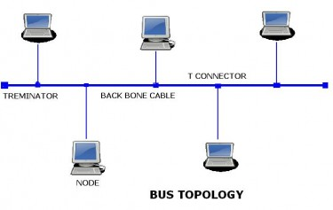
- Star Topology: A topology with a single access point or a switch (or hub) at the center of the topology and all the other nodes are connected directly to this point.
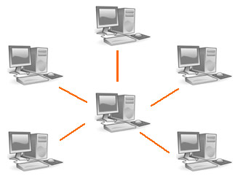
- Tree Topology: A combination of both the star and the linear bus topologies. This topology has multiple access points connected to the linear bus, while the nodes are connected to their respective access points.
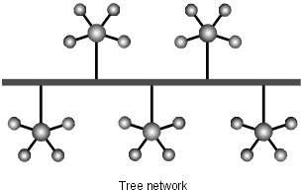
- Ring Topology: All the stations are connected in a ring and at a time only one station that contains the token can send the data so that there is no collision between the data. If a cable fails then in most of the cases there is a second ring which is used if such a condition happens.
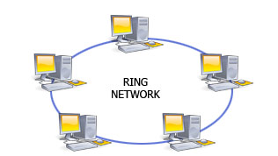
- Mesh Topology: Each station is connected using point to point connection. In this topology n*(n-1)/2 wires are required for n stations in full duplex mode.
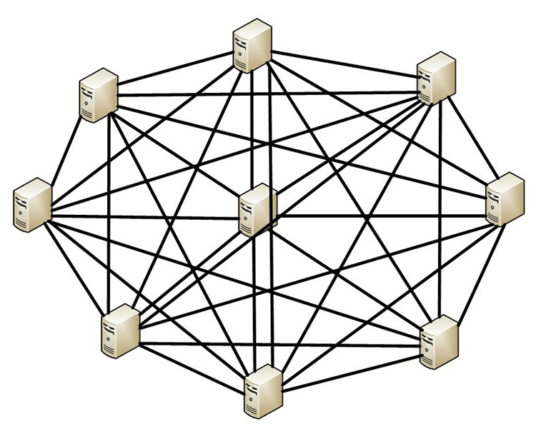

- Logical Topology
The logical topology, in contrast, is the way that the signals act on the network media, or the way that the data passes through the network from one device to the next without regard to the physical interconnection of the devices.

Q4 Classify the network as LAN, WAN and MAN.
LAN: - A Local Area Network(LAN) is a computer network that spans a relatively small area. Most often, a LAN is confined to a single room, building or group of buildings, however, one LAN can be connected to other LANs over any distance via telephone lines and radio waves.
WAN: - A system of LANs connected over a distance via telephone lines and radio waves is called a wide-area network (WAN). The difference between a LAN and WAN is that the wide-area network spans a relatively large geographical area. Typically, a WAN consists of two or more local-area networks (LANs) and are often connected through public networks.
MAN: - A metropolitan area network (MAN) is a computer network that interconnects users with computer resources in a geographic area or region larger than that covered by even a large local area network (LAN) but smaller than the area covered by a wide area network(WAN). It is used for the interconnection of networks in a city into a single larger network. It is also used for the interconnection of several local area networks by bridging them with backbone lines. The latter usage is also sometimes referred to as a campus network.

Q5 Identify the types of cable used in networking.

The types of cable used in networking are: -
Coaxial Wire: - Coaxial cabling has a single copper conductor at its center. A plastic layer provides insulation between the center conductor and a braided metal shield. The metal shield helps to block any outside interference from fluorescent lights, motors, and other computers.


Fibre Optic Cable: - Fiber optic cabling consists of a center glass core surrounded by several layers of protective materials. It transmits light rather than electronic signals eliminating the problem of electrical interference. This makes it ideal for certain environments that contain a large amount of electrical interference. It has also made it the standard for connecting networks between buildings, due to its immunity to the effects of moisture and lighting.
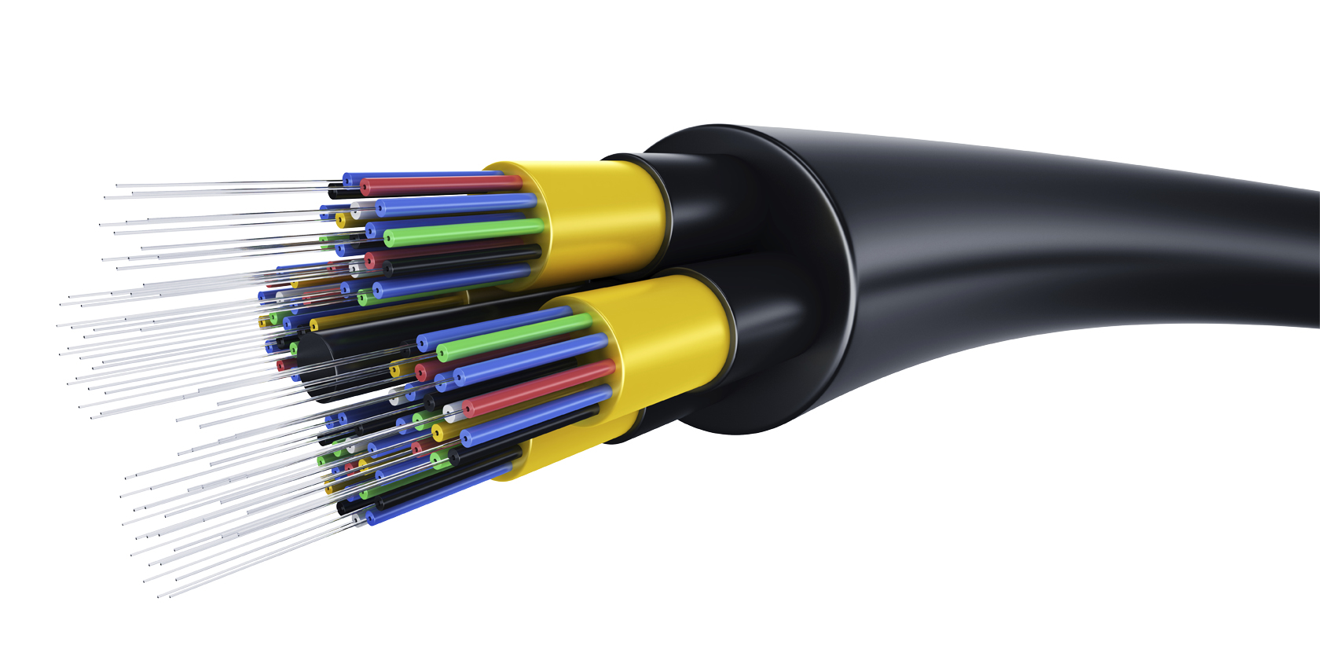

Twisted Pair Cable: -
It is of two types:
- Shielded Twisted Pair Cable:
A type of copper telephone wiring in which each of the two copper wires that are twisted together are coated with an insulating coating that functions as a ground for the wires. The extra covering in shielded twisted pair wiring protects the transmission line from electromagnetic interference leaking into or out of the cable
- Unshielded Twisted Pair Cable:
A type of cable that consists of two unshielded wires twisted around each other. UTP cabling does not offer as high bandwidth or as good protection from interference as coaxial or fiber optic cables, but it is less expensive and easier to work with.
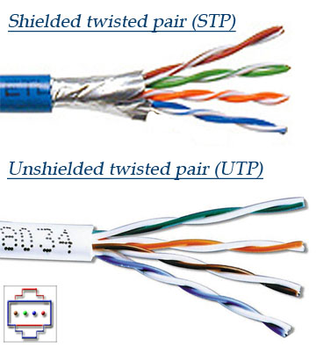

Q6 Find the Twisted pair cable standard.

